ARPIT SHARMA
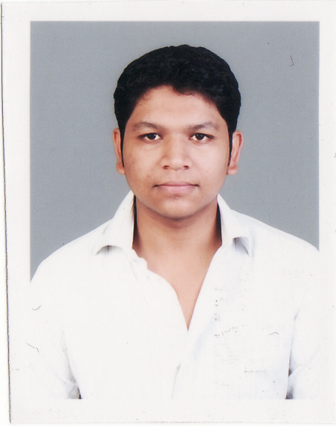
House No- B-23, Sector- 47
Noida (Uttar Pradesh)- 201301
Email id – arpit21sharma@gmail.com
Phone no. - +91 9873903021

Career Objective
- To work in a challenging, creative and professional environment that provides an opportunity to learn and excel through my enthusiasm and persistence.
- Enhance my skills and contribute towards creating a win-win situation both for me and my organization.

Professional/Academic Qualification
Degree | Institution | Board/University | Division
MBA (2012-14) | ICM, Dehradun | UTU, Dehradun | 1st Class
B. Com. (2009-12) | B.S.S.S. Bhopal | Barakatullah University, Bhopal | 1st class
12th (2008-09) | DAV School, Muzaffarnagar | UP Board | 2nd Class
10th (2005-06) | LJPSVM, Muzaffarnagar | UP Board | 1st Class

Professional Training/Projects
- I am currently working at Indusind Bank as a Sales Officer in Faridabad Branch from 1st September 2014 – till date.
- Working as a Sales Executive at Medulla-Soft Technologies Pvt. Ltd., from 3rd March 2014 – 30th August 2014.
- Undergone Profession Training of 60 days in District Cooperative Bank Ltd, Main Branch, Muzaffarnagar (UP) worked on the project “Economic Analysis” during MBA program.

Seminar/Workshops Attended
- Attended workshop on “Export-Import documentations & Procedures by NIESBUD.
- Attended seminar on “Investor Awareness Program”.

Awards and Achievements
- Stood First in “Ad-Mad Show” during MANFEST (Inter-Management Colleges Meet) held at Doon Business School, Dehradun
- Coordinator at National level College Fest

Computer Proficiency
- 3 months certificate course on “Web Designing” by Indian Institute of Entrepreneurship, Dehradun (MSME, Govt. of India)
- Sound knowledge of Windows, MS-office and Latest Application Software’s

Area of Specialization
- Major: Finance
- Minor: Rural Development

Language Known
English and Hindi

Professional Traits
Determined, Enthusiastic, Quick Learner, Meticulous, Sense of responsibility, Problem solving ability, Capability to deal with people

Hobbies/Interests
- Reading Books
- Playing Cricket and volleyball
- Creative writing

Personal Information
Marital Status : Single
Mother’s name : Ms. Kanchan Lata Sharma
Father’s name : Mr. Naresh Kumar Sharma
Date of Birth : 21/08/1990
Gender : Male
Nationality : Indian

Place: Noida
Date: (ARPIT SHARMA)

